
AN AWARD WINNER INTERNATIONAL ORGANIZATION
A_

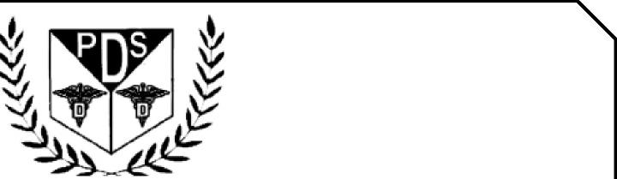
PROMOTING EXCELLENCE IN DENTAL EDUCATION
Over 10,000 Members Strong
Presents
A Must attend seminar for you and your staff
PROSTHETICS FOR GENERAL DENTIST
BY
DR SANJAY PATEL
On August 22nd , 2027(Sunday) 9:00 am till 5:00 pm
(CA Board 7 hrs. C.E. units)
at

SAPPHIRE BANQUET HALLS


24989 SANTA CLARA ST HAYWARD, CA 94544
(Please print in capital letters or attach your business card)
Name DR/RDH/RDA/DA Lic no
Circle one Name
City State Zip
Cell no ________________ Accept text message yes/no E-Mail________________________________________
ARE YOU A PDS MEMBER: YES/ NO
COMPLIMENTARY BREAKFAST, LUNCH & PARKING INCLUDED
REGISTRATION FEE |  | ONE WEEK BEFORE
Dentists Non-members | $159.00 | $169.00
Members | $149.00 | $159.00
Hygienist/R.D.A. Non-members | $139.00 | $149.00
Members | $129.00 | $139.00
FOR REGISTRATION
CALL TOLL FREE 1-866-422-5573 (1-866-4-CALL-PDS) OR 909-933-9076
TO REGISTER ONLINE VISIT US ON WWW PDSOCIETY. COM

Course Date & Time: 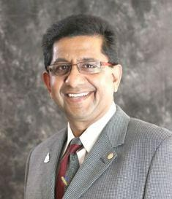

Sunday, August 22nd , 2027 9:00 am till 5:00 pm Pacific Time (US & Canada)

Duration: 7 Hours

Sanjay Patel DDS, MDS, FPFA, FACD
Dr. Patel was awarded his dental degree from the University of Gujarat, Government Dental
College &amp; Hospital. He then completed his residency in Prosthodontics. He earned his Master’s Degree
in Operative Dentistry including Endodontics. He continued his career in Academics and taught in
Gujarat and Karnataka University. His last position was an Associate Professor in Restorative Dentistry.
After practicing for 35 years in California, he has retired from his private practice. Currently he is a
faculty member in University of the Pacific (UOP) San Francisco Arthur A Dugoni School of Dentistry.

Removable Prosthetics: Back to the Basics
Fixed Prosthetics: How to use flowable composite resin to fabricate crowns
Following will be mentioned &amp; discussed in detail.
1. Being able to understand the essential steps in fabricating removable dentures
2. How to reproduce essential anatomy of dental arches.
3. Why each lab steps to fabricate denture are equally important.
4. How to design removable partial denture with proper tools.
5. Composite resin can be successfully used to make crowns with minimal preparation.
6.How to use flowable composite resins to create aesthetics with proper anatomy.

THIS EVENT IS SPONSORED BY PDS

